**DOG BREED CLASSIFICATION**

### **Abstract** — In the present world, we have wide varieties of species and organisms.Dog is a mammal that has been a friend of man for ages, it is naturally a domestic animal with a high level of phenotype differences in behaviour and morphology. Breeding and crossbreeding activities have increased the number of dog breeds globally, thereby resulting in dogs with inter breed similarities and intra breed differences thereby creating a difficulty in their classification. Dog breeds classification and some of those breeds are Boxer, BullDog and German shepord.In this we have taken and discussed about the dog breeds in our report and in this we have taken different images of dogs and By this we can predict the dogs breed .

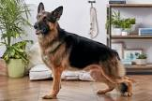

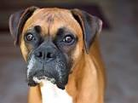

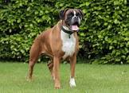

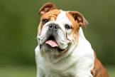

1.  **INTRODUCTION**

## Dogs are one of living organisms on our earth.These are well known for the good detective of senses like how our AI modules predict the correct outputs..and moreover in this we are taking three categories like Boxer,BullDog and German shepherd… Dog breed classification of breeds based on similarities in appearance,specified purpose,temperament and ancestry.A dog group contains a variety of dog breeds that vary dramatically in physical appearances but are similar in behaviour .The identification of dog breeds and groups is a big challenge for most people . Dog breeds can be identified using an expert-based technique; in this method, dog experts identify different varieties of dog breeds . However, this method is limited due to the availability of few dog experts and the accuracy of the method is prone to human error . The introduction of DNA tests provided an accurate and precise result however, the process is expensive and complex . Hence, there is a need to develop less expensive and automatic methods for dog breed group identification and classification.The development of artificial intelligence has outperformed human capacity in image identification and classification tasks. Also, the introduction of deep learning techniques has provided a better alternative for image classification with excellent results . The automatic classification of dog breeds into groups using the Convolutional neural network (CNN) would be an interesting research area.

## 

2.  **RELATED WORK IN DOG BREED CLASSIFICATION**

we used the good parameters like Resnet and Mobile netv2 .ResNet is a powerful deep neural network architecture that has revolutionized the field of computer vision by enabling the construction of deeper and more accurate networks.MobileNet-v2 is a convolutional neural network that is 53 layers deep. You can load a pre trained version of the network trained on more than a million images from the ImageNet database. The pretrained network can classify images into 1000 object categories, such as keyboard, mouse, pencil, and many animals. Materials and methods:

We have used the modilenetV2 model for our project.

Because while using resnet50 the accuracy is fluctuating. And the mobilenetv2 gives more accuracy then the resnet50.

MobilenetV2 gives the best result.

We have experimented nearly over 30 times with different hyperparameters by performing hyperparameter tuning and noted the best accuracy result in the hyperparameter tuning spreadsheet.

Out of 30 experiments the hyper parameter which was set to

Epoch == 20

Learning rate == 0.001

Optimizer == optimizer adam

there gives the best result in the mobilenetV2.

I take the images from the kaggle dataset. Those images are in the form of jpg or introverted_png forms. Those images help to identify the name of a character.

From the study it has been found that many approaches have been tried for classification of dogs. One of the approach is using Local Binary Pattern technique which is

used as a face recognition. This algorithm mainly provides

labels to every pixel of an image using binary numbers.

**3.APPROACH**

I had taken this dataset from kaggle and after i had extracted and created the folder name after i had started the process. First of all I had to run the code validation_split. In This first drive was mounted successfully. The next step is the path to the source and destination folder. After that we have to run some cells that list sub folders, creating duplicate folder structure , listing the files Move x% of files.. By this we had taken our dataset files to test and valid folders now we have completed first step. Second code is all about saving the best model .in every code common thing is mounting the drive and after that giving the some folder paths those are train and valid and after the running the code.i had used the Resnet giving parameters like Epochs and Learning rates giving variable values but the accuracy levels are very less and highest accuracy is only 81% .I had changed to the mobile net v2 which giving accuracy in 100% . I am pasting the image down about this accuracy.

## 

## 

## FIG:-1 FIG :-2

## 

Third step test data evaluation is also somewhat same in this also we have to give image path and test folder after running the code we will get a confusion matrix and prediction values.

After that we have to give the model path and our project name and we have to run by this we are getting the graph and confusion matrix and predictions which are placed below of this.

4. **RESULTS AND DISCUSSION**

In the above figures we observe that accuracy is given in the graphs . It gives a line plot of training and validation accuracies because using the hyper parameters like Resnet and Mobilenet v2 .we trained the model for 10,20,30 epochs and learning rates values 0.00001,0.00005,0.0001,0.001,0.01

It was observed that during the training process the training accuracy and validation accuracy were high at the start and after also becoming stable increased the epochs.

. For example:-

fig:-1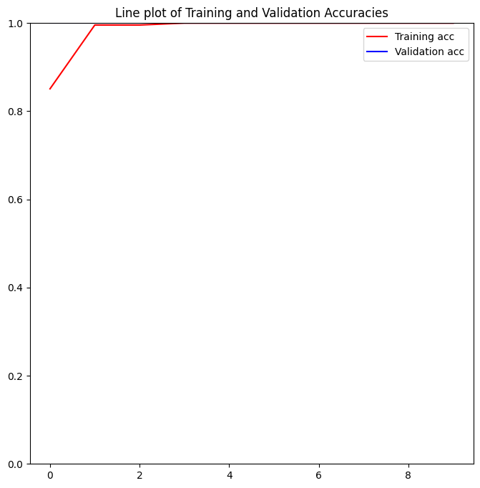

And also we having the line plot of training and validation loss .here in the training process the training loss and validation loss were giving 0% of error

FOR example :-

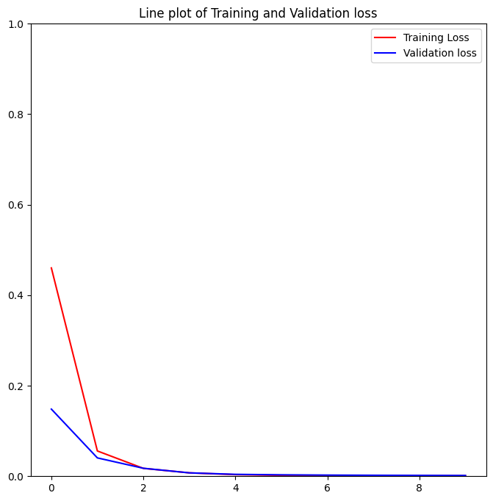

fig:-2

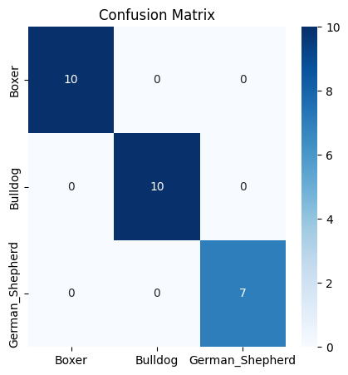 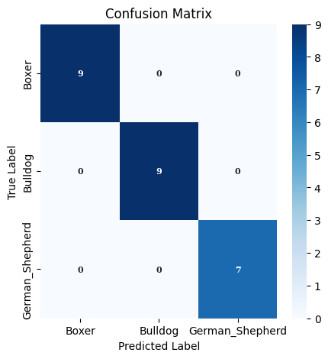

In the above confusion matrix also we observed that our model had a good performances in terms of accuracy, sensitivity and specificity.

In predictions we observes the good performances and here are the images of predictions

## 

5. **CONCLUSION**

In this work, dog breeds were automatically classified into groups based on the standard using a built convolutional neural network model. The research was performed using the open source dog dataset and the findings indicated that the developed model performed excellently in terms of accuracy, sensitivity, specificity .

The study relied on a convolutional neural network model for automatic feature extraction and classification, it might not capture the specific features of dog breed that are relevant for behavioural classifications. Hence, this work can only classify correctly the dog breeds it was trained with at high accuracy

REFERENCES

<>LINK :- <https://www.researchgate.net/publication/353693466_Dog_Breed_Classification_Using_Deep_Learning>

<>LINK:-

<https://www.kaggle.com/datasets/khushikhushikhushi/dog-breed-image-dataset>

<>LINK

<https://www.ajol.info/index.php/njtd/article/view/257219/242973>